War-test pipeline

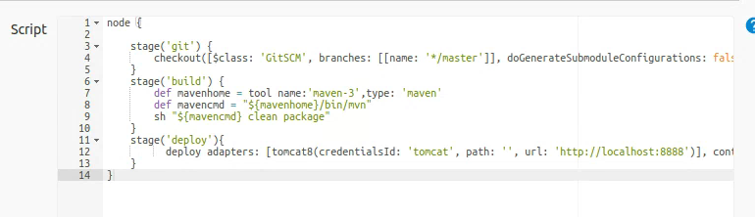

Pipeline code:

node {

stage('git') {

checkout([$class: 'GitSCM', branches: [[name: '\*/master']], doGenerateSubmoduleConfigurations: false, extensions: [], submoduleCfg: [], userRemoteConfigs: [[url: '<https://github.com/shubhamkushwah123/war-test.git>']]])

}

stage('build') {

def mavenhome = tool name:'maven-3',type: 'maven'

def mavencmd = "${mavenhome}/bin/mvn"

sh "${mavencmd} clean package"

}

stage('deploy'){

deploy adapters: [tomcat8(credentialsId: 'tomcat', path: '', url: '<http://localhost:8888>')], contextPath: 'warfile', war: '\*\*/\*.war'

}

}